Software Requirement Specification
Tahafuz
B.S. in Computer Engineering, Batch 2021F

Project Advisor:
Engr Saba Ahsan
Assistant Professor

Submitted By:

Muhammad Umair (GL)
Mir Muhammad
Muhammad Huzaifa Anwar
Umees Ur Rehman

2021F-BCE-231
2021F-BCE-178
2021F-BCE-206
2021F-BCE-257
DEPARTMENT OF COMPUTER ENGINEERING
Sir Syed University of Engineering & Technology
University Road Karachi - 75300
April 2025

Contents

1 | Software Requirement Specification | 1
 | 1.1 Introduction . . . . . . . . . . . . . . . . . . . . . . . . . . . . . . . . .. . | 3
 | 1.1.1 Product Purpose . . . . . . . . . . . . . . . . . . . . . . . . . . .. | 3
 | 1.1.2 Product Scope . . . . . . . . . . . . . . . . . . . . . . . . . . . . . . | 3
 | 1.1.3 System Diagram & Description . . . . . . . . . . . . . . . . . .. . | 4
 | 1.1.4 Project Stakeholders . . . . . . . . . . . . . . . . . . . . . . . .. . | 6
 | 1.1.5 Project WBS & Gantt Chart . . . . . . . . . . . . . . . . . . . . .. | 7
 | 1.2 Project Functional Requirements . . . . . . . . . . . . . . . . . . . . .. . | 7
 | 1.2.1 Project Functional Features . . . . . . . . . . . . . . . . . .. | 7
 | 1.2.2 Operating Environment . . . . . . . . . . . . . . . . . . . . . . . . . . . . | 8
 | 1.2.3 UX Prototype . . . . . . . . . . . . . . . . . . . . . . . . . . . . . . | 9
 | 1.3 Project Non-Functional Requirements . . . . . . . . . . . . . . . . . .. . | 10
 | 1.3.1 Performance Evaluation . . . . . . . . . . . . . . . . . . . . . . . . | 10
 | 1.3.2 Safety Requirements . . . . . . . . . . . . . . . . . . . . . . . . . . | 10
 | 1.3.3 Security Requirements . . . . . . . . . . . . . . . . .. . . . . . . .. | 11
 | 1.3.4 Business Perspective/Requirements . . . . . . . . . .. . . . . .. . | 11
 | 1.3.5 Licensing Requirements . . . . . . . . . . . . . . . . . . . . . . . . | 12
 | 1.3.6 Legal Copyrights & Notices . . . . . . . . . . . . . . . . . . . . .. | 12
 | 1.4 Software Design Methodology . . . . . . . . . . . . . . . . . . . . . . . . | 12
 | 1.4.1 Data dictionary / Data set . . . . . . . . . . . . . . . . . . . . . . . | 12
 | 1.4.2 Design Models [along with descriptions] . . . . . . . . . . . . . . | 13
1.5 External Interfaces Requirements . . . . . . . . . . . . . . . . . . . . . . 15

List of Figures

  - Tahafuz Flow diagram……………………………………………………………………………………. 4
  - Tahafuz Process Diagram…….……………………………………………………………………. 5
  - Project WBS Gantt Chart …….……………………………………………………………………………. 7
  - UI UX Prototype…….……………….……………………………………………………………………. 9
  - Use Case Diagram …………………………………………………………………………………………. 13
1.6 Entity Relationship Diagram ………………………………………………………………………. 14
1.7 Sequence Diagram ………………………………………………………………………………………. 15
Software Requirement Specification
A software requirements specification (SRS) is a document that describes what the software will do and how it will be expected to perform. It also describes the functionality the product needs to fulfill the needs of all stakeholders (business, users).

Introduction

Product Purpose

The Tahafuz is an all in one women safety solution, designed to help women’s in critical condition. It includes a mobile app which is integrated with a wearable IoT device. Tahafuz aims to bridge the gap between the existing safety solutions by offering offline functionality, discreet activation, and real-time alerting through a wearable IoT device. Tahafuz empowers users to protect themselves, record critical evidence, and connect instantly with trusted contacts, ensuring help is always within reach, even without internet. Tahafuz is designed with keeping focus on affordability, usability, and real-time response, with the goal of ensuring safety even in areas with poor connectivity. The product can be modified for upcoming safety improvements and is scalable for mass deployment.

Product Scope
Tahafuz is a mobile-based safety solution supported by a compact wearable IoT device. The product is designed to provide women with a discreet and instant way to send SOS alerts using a shake gesture or device button. Once activated, the system shares the user’s live location with trusted contacts and begins recording audio — even without internet, thanks to local SD card storage. The app also displays nearby emergency services like hospitals and police stations for quick access. Simple, intuitive, and built for both online and offline environments, Tahafuz is the complete solution to the problem of delayed emergency response and lack of real-time evidence in critical situations.

System Diagram & Description

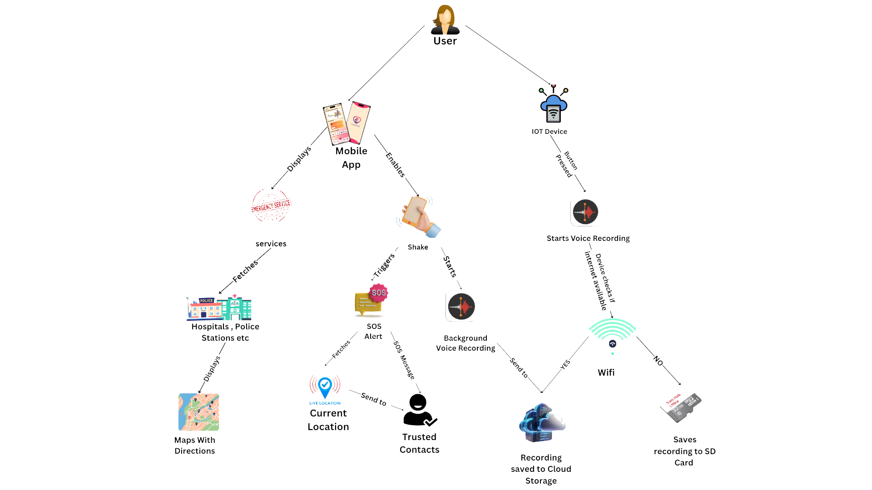

Figure 1.1: Tahafuz Flow Diagram

Description:
Tahafuz is reliable safety solution created to support women during real-life emergencies. It combines a user-friendly mobile app with a discreet wearable IoT device to help users quickly send alerts, share their location, and record audio as an evidence when it matters most. The system offers:
- A mobile application that let users trigger SOS alerts instantly with a simple mobile shake or manually from the application.
- Real-time location sharing with trusted contacts to ensure help reaches on time.
- Access to nearby emergency services like hospitals or police stations through the app interface.
- A compact IoT device that starts recording audio offline when activated, storing voice recording safely on an SD card and also on cloud.
- A simple, affordable design that works even without internet, making it practical for everyday use.
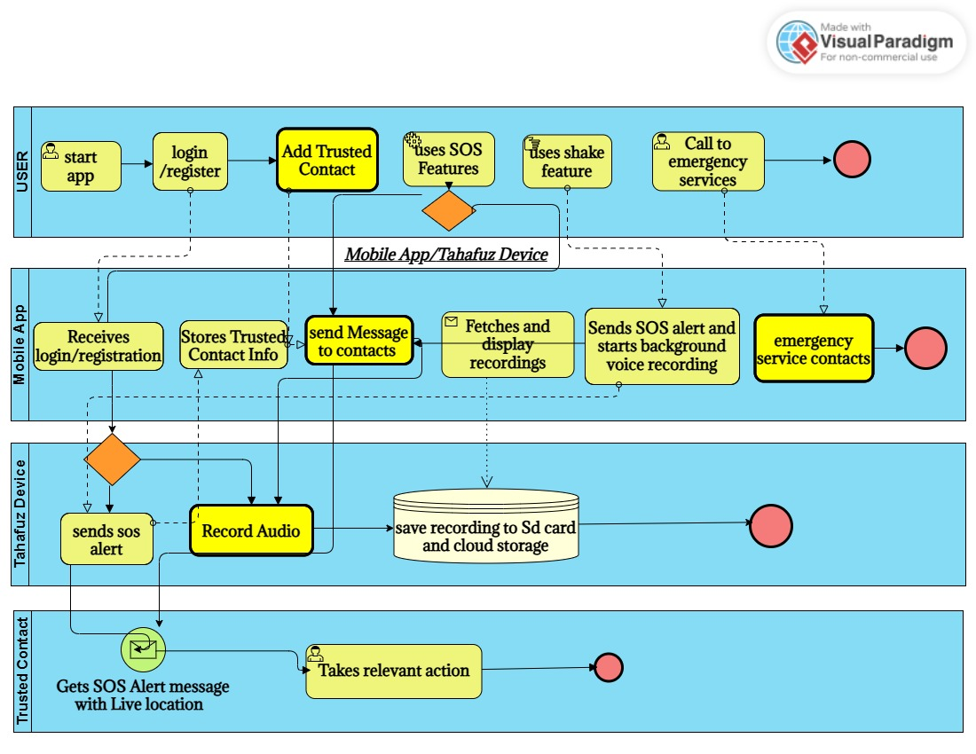

Figure 1.2: Tahafuz process diagram

Project Stakeholders
The success of the Tahafuz depends on the collaboration and involvement of multiple stakeholders. These individuals and groups influence the development of the application from various dimensions, such as design, functionality, reliability, and deployment.
- End Users (Women & Female Commuters):
The primary beneficiaries who will use the app and wearable device during emergencies.
- Development Team:
Responsible for designing, developing, and maintaining the mobile app and IoT hardware.
- Investors & Funding Bodies:
Provide financial support for product development, manufacturing, and scaling.
- Cloud Service Providers:
Offer secure storage for audio recordings and user data.
- Emergency Services (Hospitals, Police, Helplines):
Indirect stakeholders who may be contacted or shown through the app’s emergency map.
- Law & Policy Advisors:
Ensure legal compliance with privacy, data protection, and evidence laws.
- Manufacturing Partners:
Assist in mass production and cost-effective assembly of the IoT devices.

Project Sponsor | SIR SYED UNIVERSITY OF ENGINEERING & TECHNOLOGY
Stakeholder | Students Names:  • Muhammad Umair (GL) – 2021F-BCE-231  • Mir Muhammad – 2021F-BCE-178  • Muhammad Huzaifa – 2021F-BCE-206  • Umees Ur Rehman – 2021F-BCE-257  Project Supervisor Name: Engr Saba Ahsan  Final Year Project Committee

Project WBS & Gantt Chart



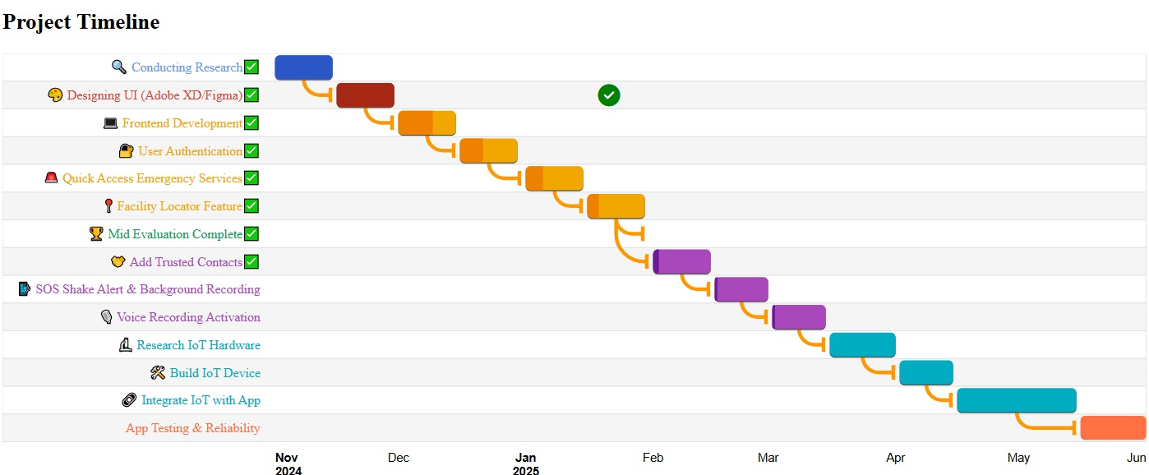
Figure 1.3: Gantt Chart

Project Functional Requirements
    - Product Functional Features
Context & Origin:
Tahafuz is an entirely new safety solution no predecessor product or version—designed from the ground up to protect women in emergencies by combining a mobile app with a wearable IoT device.
Core Functionalities:
- SOS Activation: Detects shake gesture or button press to trigger an alert.
- Location Sharing: Captures and transmits real‑time GPS coordinates to trusted contacts.
- Voice Recording: Records audio locally to SD card; syncs to cloud when online.
- Emergency Directory: Displays nearby hospitals, police stations, and medical stores.
- Contact Management: Manages a list of trusted contacts for instant notifications.

Operating Environment
The system shall operate in the following environments and contexts:
Hardware Platforms:
- Wearable IoT Device: ESP32 microcontroller, MEMS microphone, SD card interface, Li Po battery (≤ 50 g total).
- User Devices: Smartphones running Android (Android 8 or higher) or iOS (version 12 or higher), with GPS, accelerometer, and Bluetooth/Wi Fi.
Software Platforms:
- Mobile App: React Native framework (JavaScript) for cross platform deployment.
- Backend Services: Backend using Node.JS/Express.js
- Database: MongoDB and for cloud Firebase will used
Deployment Topology:
- Cloud Hosting: Firebase services hosted in the Asia Pacific region (Google).
- APIs & Services: Google Maps APIs for location services, Firebase Cloud for cloud storage, SMS API to send messages.
- Data Centers: Managed by Google (Firebase) and AWS for redundancy.

Design & Implementation Constraints

Constraint Type | Details | Rationale
Programming Language | React Native (JS) & Node.js | Leverages team expertise and enables shared code across web and mobile
Database | MongoDB | Flexible schema for user profiles, alerts, and logs
APIs | RESTful architecture | Industry‑standard for interoperability and easy integration
Authentication | JSON Web Tokens (JWT) in Node.js | Lightweight, secure, and fully controlled by our backend
Table 1.4 Technical Constraints

Project Functional Requirements

Feature Name | Functional Requirement
User Authentication | The system shall allow users to sign up and log in using email and password with secure authentication service
Emergency Alert (SOS) | The system shall send an SOS alert with the user’s current location in real time to all pre-configured emergency contacts when the button is pressed or a shake gesture is detected.
Location Tracking | The system shall capture and transmit the user’s current GPS location to trusted contacts continuously during an active SOS session.
Audio Recording | The system shall automatically start audio recording on both the mobile app and the IoT device when an SOS is triggered.
Audio Uploading | The system shall store recorded audio locally on the SD card if offline and upload it to Firebase Cloud Storage once connectivity is restored.
User Profile Management | The system shall enable users to add, edit, or remove their personal details and emergency contacts through the app dashboard.
Hardware Sync | The system shall detect when the wearable device connects via Bluetooth and automatically sync recorded audio.

1.2.3 UX Prototype
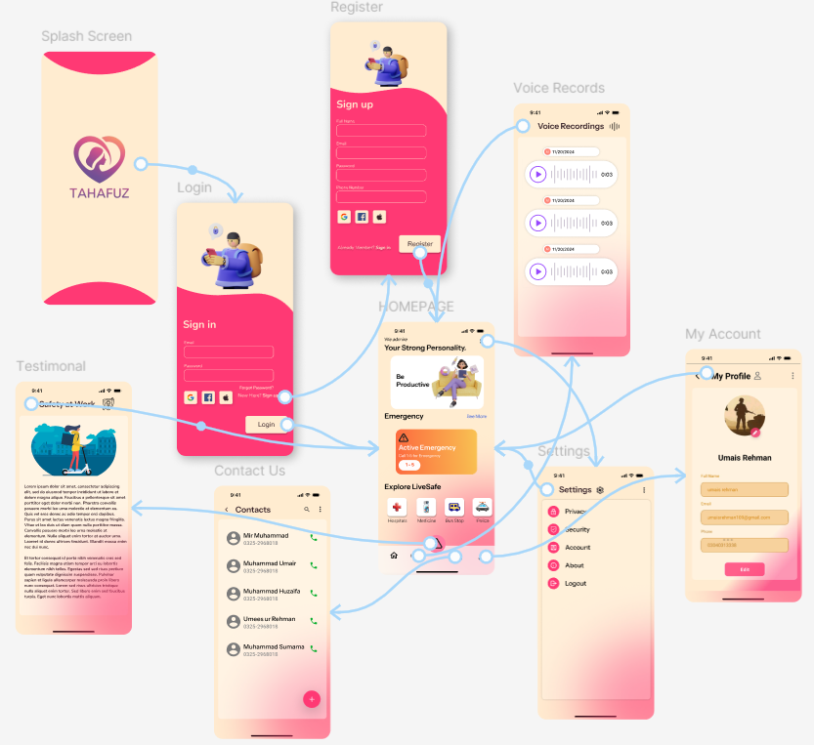
Figure 1.4: (UI UX Mobile)

Project Non-Functional Requirements

Performance Evaluation
In the context of the Tahafuz, the following performance evaluation criteria are defined to ensure the app delivers optimal performance during key operations. The performance requirements are categorized based on different system operations and features:
The system shall send SOS alerts and location to all trusted contacts immediately after activation.
- Audio recording shall begin immediately (≤1 second delay) after SOS is triggered.
- The app shall retrieve and display nearby emergency services.
- Audio files will be immediately sent to cloud/SD card immediate after recording (depending on network speed).
- The system shall support up to 10 simultaneous contact notifications without delay.
- IoT device battery shall last minimum of 1.5-2 hours (depending on usage).
These performance evaluations ensure that the Tahafuz operates efficiently, delivering reliable emergency response functionality and optimal user experience under various conditions.

Safety Requirements
The Tahafuz is designed to ensure the safety and well-being of women’s during emergency situations. The following safety requirements and safeguards are defined:
- The system shall not collect or transmit user data without explicit user permission, ensuring compliance with Pakistan’s Personal Data Protection Act.
- All voice recordings shall be locally encrypted and only uploaded to cloud storage when a secure connection is available.
- The wearable IoT device shall be safe to wear, lightweight, non-heating, and built from skin-friendly materials.
- The system shall only activate voice recording after an SOS trigger initiated by the user (via shake or device button).
- The app and device shall not interfere with other applications or systems on the user’s phone.
- The hardware shall comply with basic electronic safety and wireless transmission standards applicable in Pakistan.

Security Requirements

- Authentication: The system shall require secure login (JWT or Firebase Auth) before any SOS or location actions.
- Encryption: All data in transit shall use TLS 1.2+; all stored data (voice logs, location) shall use AES-256.
- Access Control: Only authenticated users and their trusted contacts shall access SOS alerts and recordings.
- Privacy Compliance: The system shall adhere to Pakistan’s Personal Data Protection Act and relevant telecom regulations.
- Audit Logging: The system shall record all SOS triggers, logins, and data uploads for 90 days to monitor security events.
    - Business Perspective/Requirements
- Target Industry / Market
- Women’s personal safety technology and IoT wearables
- Emergency response and location-based services
- Growing demand in urban and semi-urban regions
- Competitor Analysis
- bSafe, Noonlight, Punjab women safety app: App-only solutions lacking offline evidence capture and wearable device.
- Tahafuz Edge: Combines wearable IoT + offline recording
- Potential Customers
- Women commuters and students seeking discreet protection
- Working professionals in high-risk or low-connectivity areas
- Women Organizations (colleges, ride-share services) providing safety benefits
- Scalability / Extensibility
- Modular design allows adding features (fall detection, video capture)
- Cloud backend scales to millions of users and audio files
- Adaptable to other user segments (elderly, children) and regions

Licensing Requirements
The Tahafuz will comply with the following:
- Data Protection Compliance: Register with the relevant authority under Pakistan’s Personal Data Protection Act to legally process and store user data.
- App Store/play Store Licensing: Maintain valid developer accounts and comply with Google Play and Apple App Store guidelines for distribution and updates.
- Quality & Safety Standards: Maintain high standards for information security and electrical safety in device manufacturing.

Legal Copyrights & Notices
- Copyright © 2025, SSUET. All rights reserved.
- This software product is protected by copyright law and international treaties. Unauthorized reproduction, distribution, or modification of the software is strictly prohibited.

Software Design Methodology

The Tahafuz follows the Object-Oriented Programming (OOP) methodology, allowing for scalable, maintainable, and reusable code. The Agile Model is used for development, enabling iterative development and fast changes based on feedback. The app's core features (e.g., user authentication, SOS alert system, and audio recording are implemented as independent objects with specific attributes and behaviors.

Data dictionary / Data set
Here’s a list of the key entities and their descriptions:
- User: Represents an individual using the app.
  - Attributes: user_id, name, email, phone number, password, location, emergency contacts
  - Methods: login (), register (), update Profile ()

- Emergency Contact: Represents a contact that will receive alerts.
  - Attributes: contact name, contact number
  - Methods: send Alert ()
- SOS Alert: Represents an SOS request sent by the user.
  - Attributes: user_id, location, timestamp, audio recording
  - Methods: send Alert (), store Recording ()

Design Models

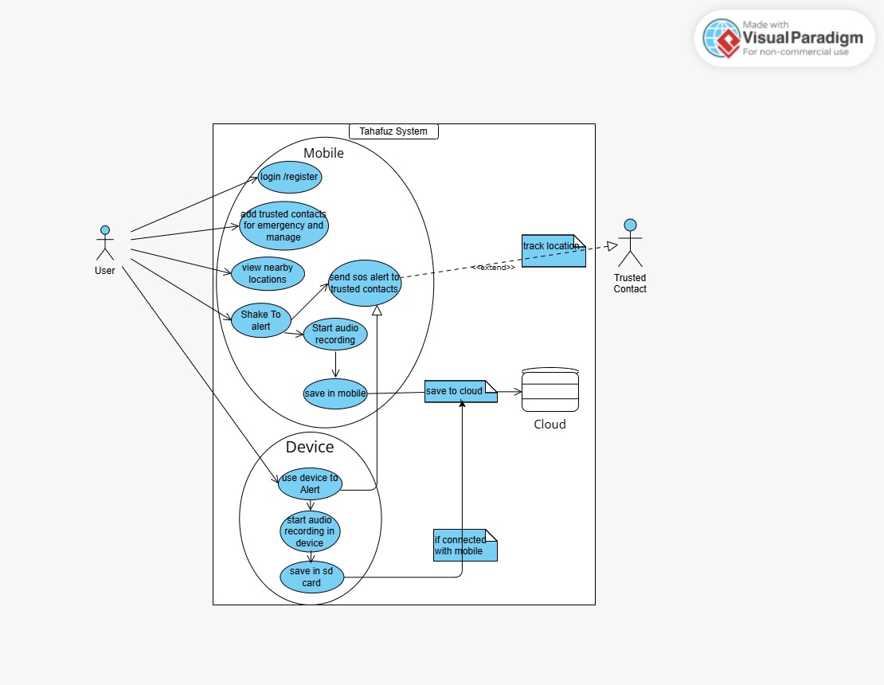
Figure 1.5: (Use Case diagram)

Actors:
- User – registers, manages contacts, views nearby services, and triggers SOS alerts.
- IoT Device – captures audio and sends alert signals to the app.
- Trusted Contact – receives SOS alerts and views the sender’s location.
Core Use Cases:
- User Operations: Registration & login, emergency contact management, and service lookup.
- Emergency Actions: Shake-to-alert or button press triggers SOS, audio recording, and location sharing.
- Device Interactions: Device records audio locally (SD card) and syncs it to the app.
- Data Management: App stores recordings locally and uploads them to the cloud.
- Trusted Contact Actions: Contacts receive alerts and can update their own info.

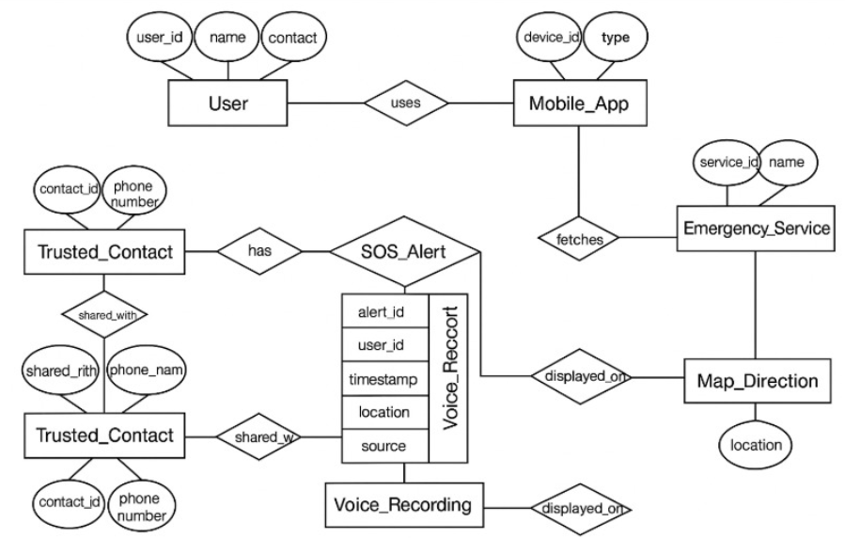
Figure 1.6: (Entity Relationship Diagram)
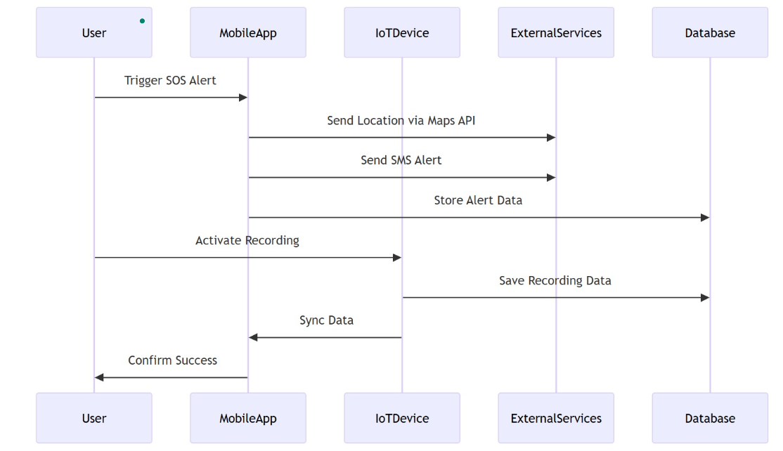
Figure 1.7: (Sequence Diagram)

External Interfaces Requirements
1. User Interfaces
- Screens: Simple, consistent layout across app: Home, SOS, Contacts, Map, Settings.
- Controls: Standard buttons (Help, Back), gesture support (shake SOS), and one-tap actions.
- Feedback: Inline error messages, confirmation toasts, and visual SOS status indicator.
2. Hardware Interfaces
- Wearable IoT Device: ESP32 communicates via Bluetooth Low Energy (BLE) to the mobile app.
- Microphone & SD Card: Audio data streams from mic to SD card; control via I²C/SPI protocols.
- Battery & Charging: USB-C power and status LEDs.
3. Software Interfaces
- Mobile App: React Native (v0.70+) on Android (API 8+) and iOS 12+.
- Backend: Node.js (v14+) Firebase Functions; Fire store and Cloud Storage.
- Maps & SMS API: Google Maps SDK; SMS API for messaging.
4. Communications Interfaces
- Protocols: HTTPS for API calls and BLE (Bluetooth Low Energy) for device pairing.
- Data Sync: Offline queue with automatic retry on reconnect.
- APIs: RESTful JSON endpoints for alerts, locations, and recording uploads.

